CONTROL AND COORDINATION

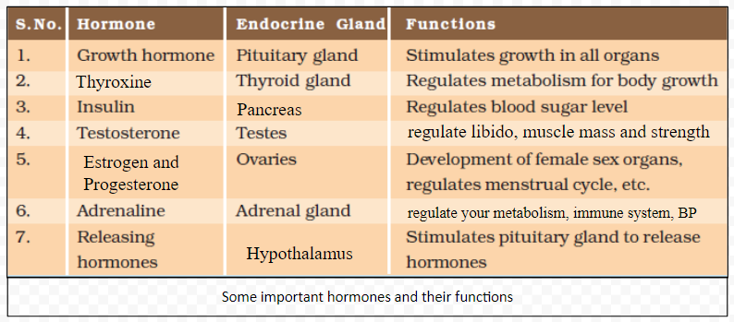
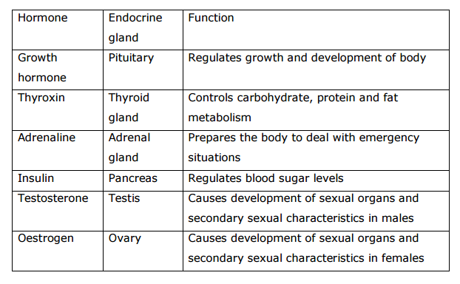
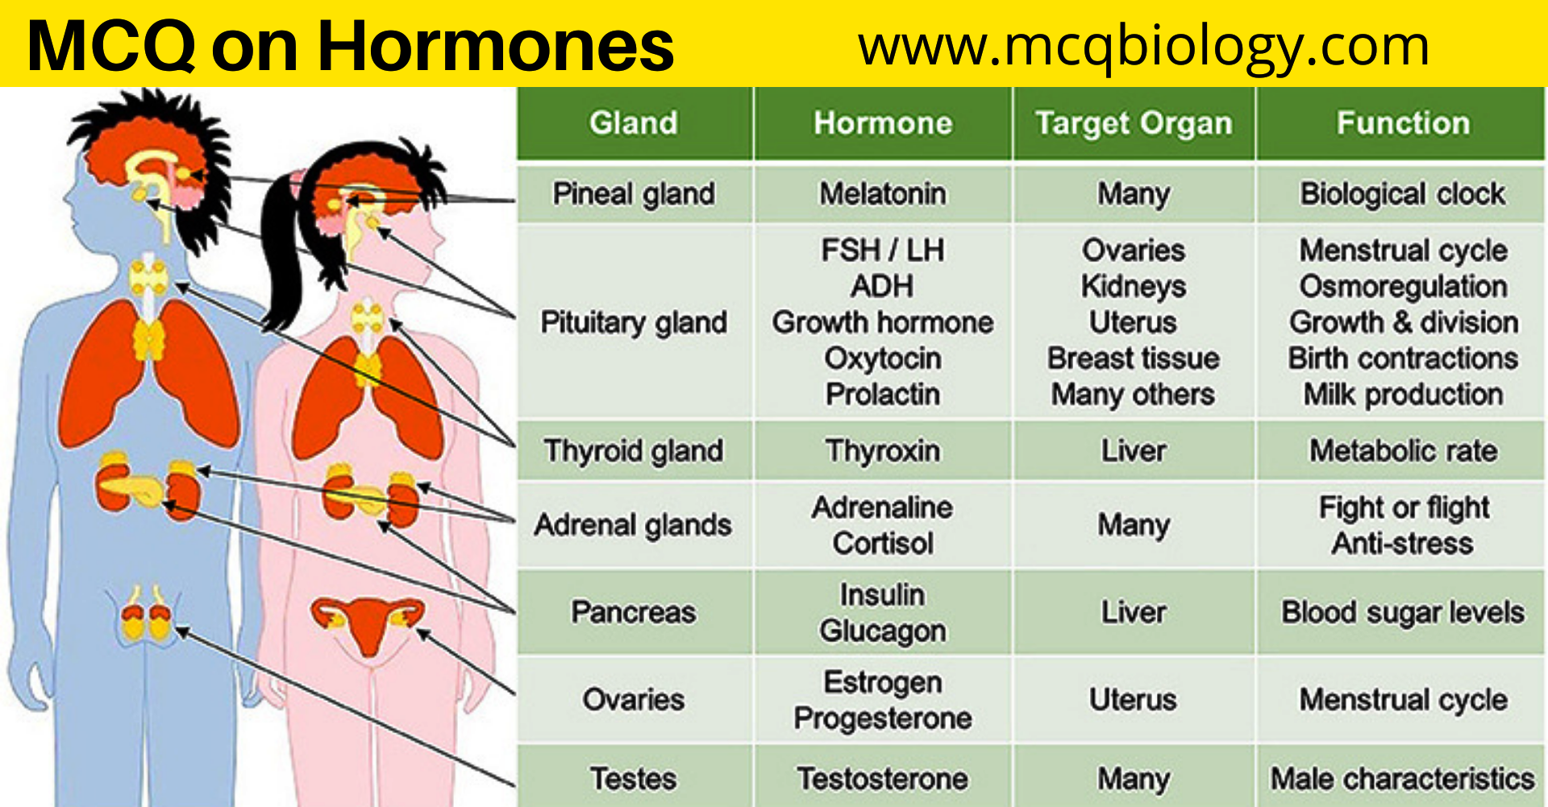

MATCH

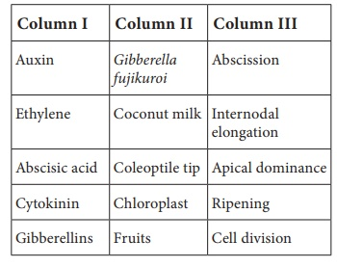

Match the following hormones with their deficiency states
Hormones Disorders
a) Thyroxine - Acromegaly
b) Insulin - Tetany
c) Parathormone - Simple goitre
d) Growth hormone - Diabetes insipidus
e) ADH - Diabetes mellitus
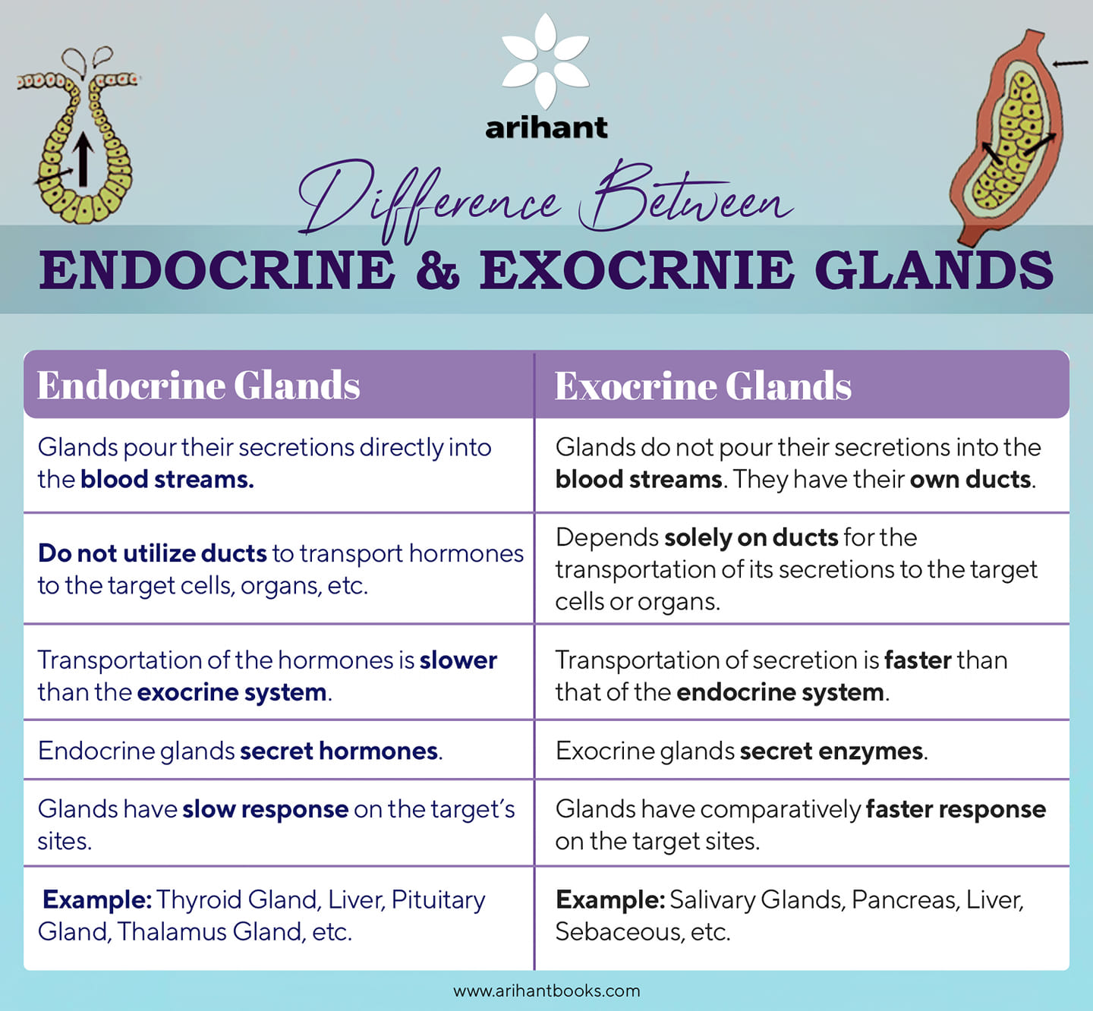

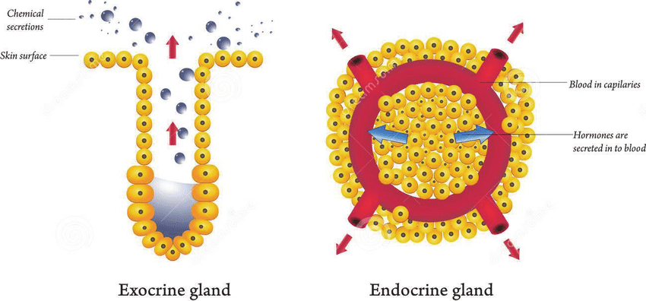
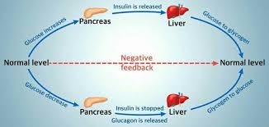

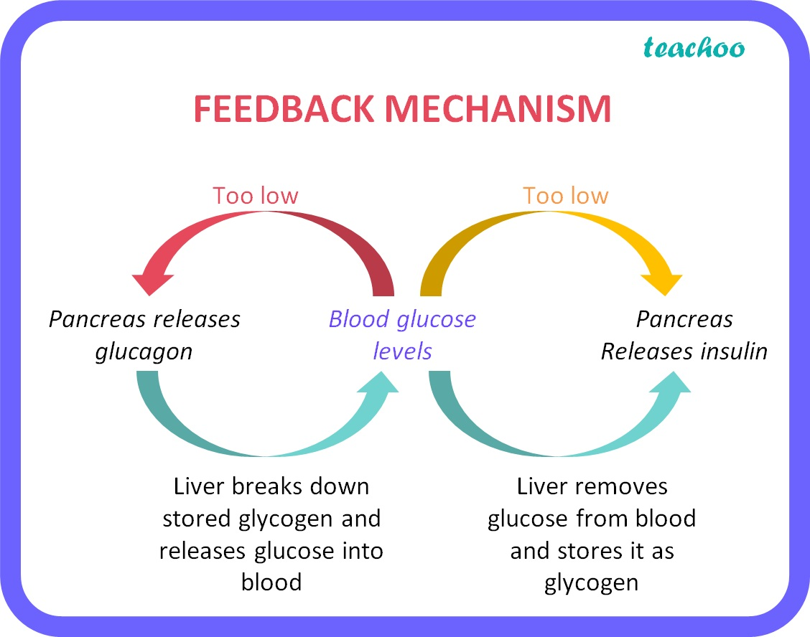

Higher Order Thinking Skills (HOTS)
1. What would be expected to happen if
a. Gibberellin is applied to rice seedlings.
b. A rotten fruit gets mixed with unripe fruits.
c. When cytokinin is not added to culture medium
a. Gibberellin will cause internodal elongation in rice.
b. The rotten fruit will produce lot of Ethylene and the unripe fruits will begin to ripen quickly.
c. Cytokinin induces cell division. If it is not added to culture medium, division of cells will not occur and the cultured tissue will not show growth.
3. A plant hormone was first discovered in Japan when rice plants were suffering from Bakanae disease caused by Gibberella fujikoroi. Based on this information answer the following questions:
a. Identify the hormone involved in this process.
b. Which property of this hormone causes the disease?
c. Give two functions of this hormone.
a. Gibberellin
b. Application of gibberellins on plants stimulate extraordinary elongation of internode. This causes Bakanae disease.
c. 1. Gibberellin breaks dormancy of Potato tubers.
2. They promote the production of male flowers in monoecious plants (Cucurbits).
4. Senthil has high blood pressure, protruded eyeball and an increased body temperature. Name the endocrine gland involved and hormone secretion responsible for this condition.
Endocrine gland - Thyroid gland.
Hormone - Thyroxine (Excess secretion).
5. Sanjay is sitting in the exam hall. Before the start of the exam , he sweats a lot, with increased rate of heart beat. Why does this condition occur?
Sanjay is sitting in the exam hall. He is tensed about the exam and is worried. In stressful situation, the hormone Adrenaline is produced by Adrenal gland. It helps the body to handle stressful situations as follows and is produced during conditions of stress and emotion.
(i) It increases heart beat and blood pressure.
(ii) It decreases blood flow through the skin. Thus Sanjay sweats a lot and has increased rate of heart beat.
6. Susan’s father feels very tired and frequently urinates. After clinical diagnosis he was advised to take an injection daily to maintain his blood glucose level. What would be the possible cause for this? Suggest preventive measures.
(i) Susans' father must be suffering from Diabetes mellitus.
(ii) Due to deficiency of the hormone insulin produced by the pancreas his blood sugar level would have increased.
(iii) Therefore he would have been advised to take insulin injection daily to maintain his blood glucose level.
(iv) Frequent urination is a symptom of the disease and excess glucose is also lost from the body through urine. Therefore he would feel tired.
Preventive measures for Diabetes Mellitus :
(i) Intake of foods rich in protein and avoid sugary foods like fruit juices, fruits, starchy vegetables.
(ii) Regular physical exercise.
Intake of whole grains and wheat based products.
